**Project Design Phase-II**

**Data Flow Diagram & Flow Chart**

|  |  |
| --- | --- |
| **Date** | 17 October 2022 |
| **Team ID** | PNT2022TMID14537 |
| **Project Name** | Gas Leakage Monitoring & Alerting System For Industries |
| **Maximum Marks** | 4 Marks |

**Data Flow Diagram:**

A Data Flow Diagram (DFD) is a traditional visual representation of the information flows within a system. A neat and clear DFD can depict the right amount of the system requirement graphically. It shows how data enters and leaves the system, what changes the information, and where data is stored.

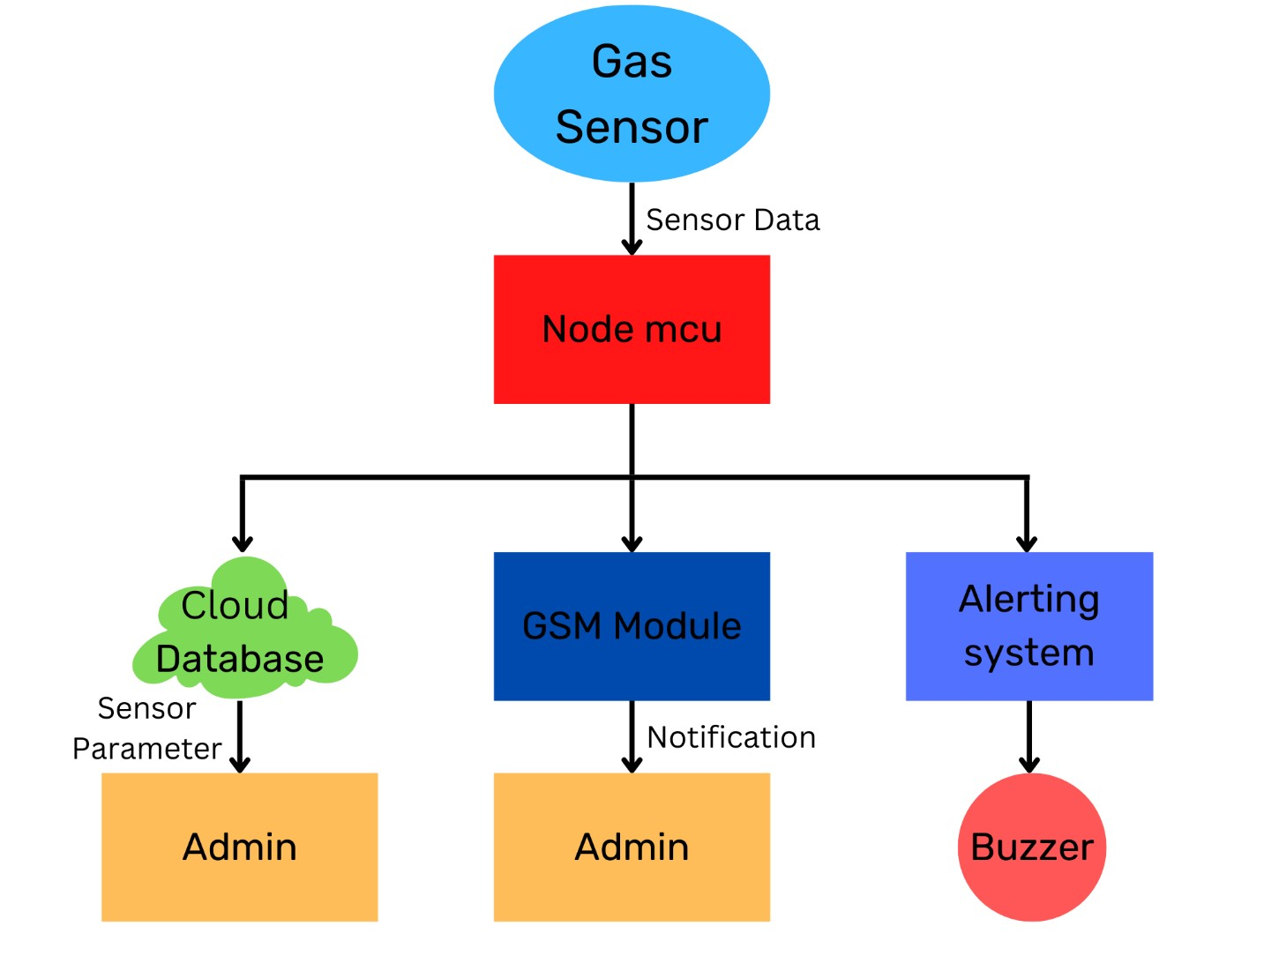

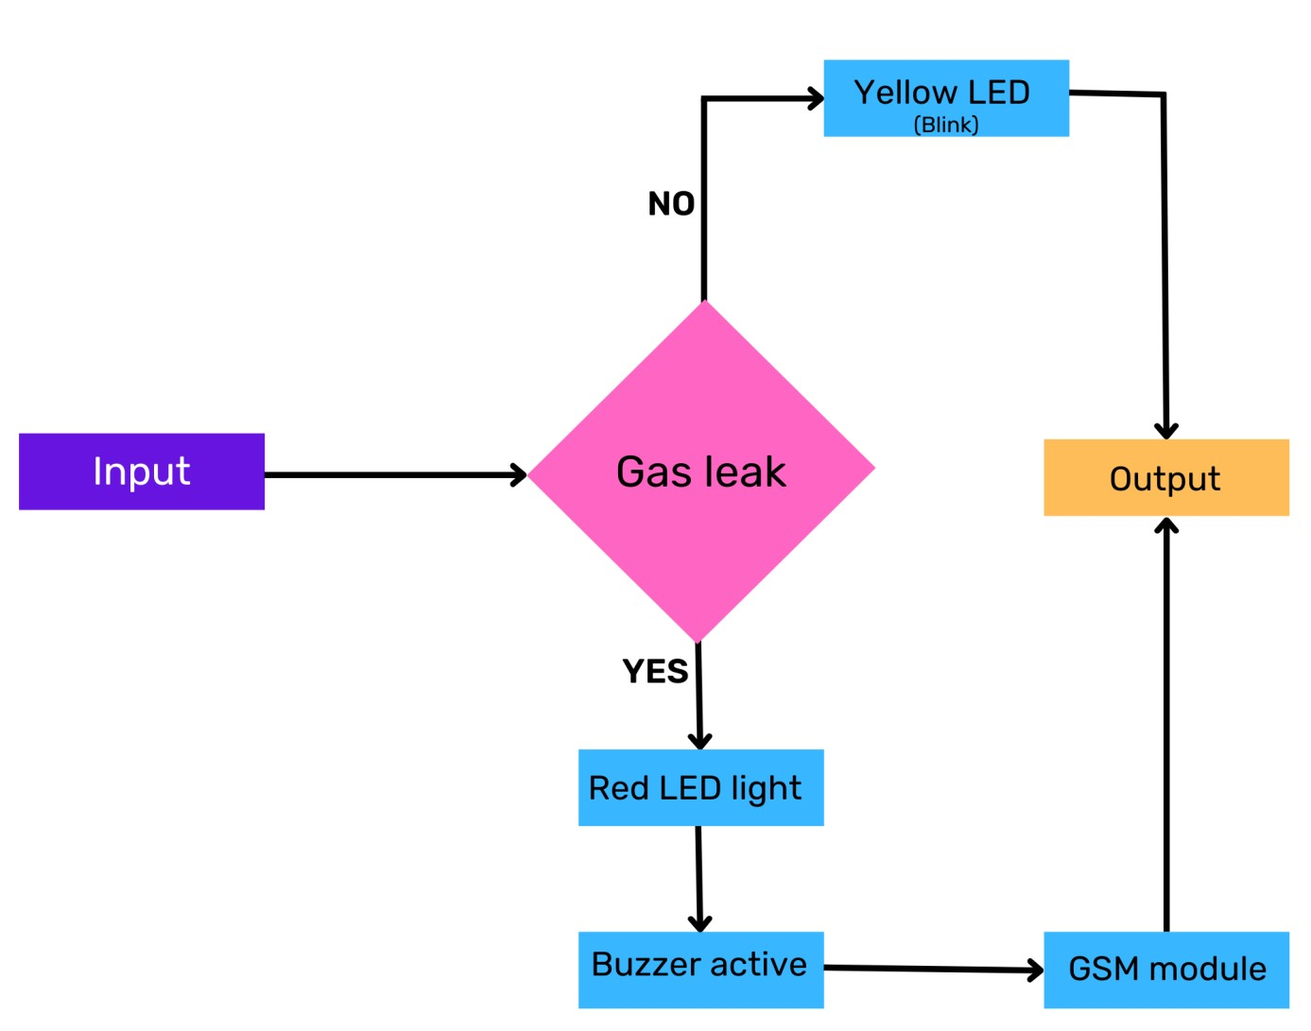

**User Stories:**

|  |  |  |  |  |  |  |
| --- | --- | --- | --- | --- | --- | --- |
| **User Type** | **Functional**  **Requirements**  **(EPIC)** | **User**  **Story**  **Number** | **User**  **Story/Task** | **Acceptance Criteria** | **Priority** | **Release** |
| Customer  (application) | Registration | USN-1 | As a user, I can register for the application by entering my email, password, and confirming my password. | I can access my account / dashboard | High | Sprint-1 |

|  |  |  |  |  |  |  |
| --- | --- | --- | --- | --- | --- | --- |
|  |  | USN-2 | As a user, I will receive confirmation email once I have registered  for the application | I can receive confirmatio n email & click  confirm | Medium | Sprint-1 |
|  |  | USN-3 | As a user, I can register for the application through Gmail |  | Medium | Sprint-1 |
|  | Login | USN-4 | As a user, I can log into the application by entering email & password |  | High | Sprint-1 |
|  | Dashboard | USN-5 | As a user, I can login with my credentials to see my dashboard | I will be able to see my dashboard and the application | High | Sprint-2 |
| Customer (Web user) | Dashboard | USN-6 | As a web user, I will go to the application’s URL and login by entering my credentials | I will be able to login and view my dashboard | Medium | Sprint-2 |
| Customer  Care  Executive | Helping the customers | USN-7 | As a customer care person, I will respond to the customer’s queries | I will be able to see the customer’s difficulties, queries and feedback | High | Sprint-3 |
| Administrat or | Working with data | USN-8 | As an administrator, I can login to the application’s server | I will be able to view the applications data server | High | Sprint-3 |
|  | Asking and responding | USN-9 | As an administrator, I can ask and respond to the customer’s questions | I will be able to answerable to the customers | Medium | Sprint-4 |
|  | Maintaining the database | USN-10 | As an administrator, I will be able to view the database | I will be able to view, modify and maintain the application’ s database | High | Sprint-4 |
|  | Managing the overall process | USN-11 | As an administrator, I can control the overall process | I can control and maintain the overall application’ s process | High | Sprint-4 |